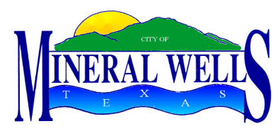

City of Mineral Wells
P O Box 460, Mineral Wells, Texas 76068
Telephone: 940.328.7700 Fax: 940.328.7704

NOTICE OF MEETING

The Mineral Wells City Charter Review Commission will hold a regular meeting at 5:30 PM on Thursday, July 17, 2025, in the City Council Chambers at the City Hall Annex, 115 S.W. 1st Street, Mineral Wells, Texas, to consider the following agenda:

- Call to Order and Establish a Quorum

- PUBLIC COMMENT
This is an opportunity for the public to address the City Charter Review Commission regarding an item on the agenda, except for public hearings that are included on the agenda. Comments related to public hearings will be heard when the specific hearing begins. Public comments are limited to three (3) minutes per speaker, unless the speaker requires the assistance of a translator, in which case the speaker is limited to six (6) minutes, in accordance with applicable law. To address the City Charter Review Commission, each speaker who is present at the site must complete a Speaker Form and provide it to the City Clerk before the start of the meeting. Each speaker shall approach the designated speaker location and state his/her name and city of residence before speaking. Speakers shall address the City Charter Review Commission with civility that is conducive to appropriate public discussion. Speakers can address only the City Charter Review Commission and not individual officials, commission members, committee members, or employees. The public cannot speak from the gallery but only from the designated speaker location.

- APPROVAL OF THE MINUTES OF THE REGULAR MEETING HELD ON MAY 15, 2025

- DISCUSS AND CONSIDER AMENDMENTS TO ARTICLES I & II OF THE CHARTER

- DISCUSS AND ASSIGN THE COMMISSION WITH REVIEW OF ARTICLE III OF THE CHARTER

- DISCUSS AND CONSIDER THE NEXT MEETING DATE

- ADJOURN

Notes: Disabled persons requiring special assistance are requested to notify the City of Mineral Wells 24 hours in advance of the meeting by calling the City Clerk’s office at 940.328.7702.

State of Texas §
City of Mineral Wells §

I hereby certify that notice of this meeting of the Mineral Wells City Charter Review Commission was posted by 5:30 pm on the 11th day of July 2025.
GIVEN UNDER MY HAND AND SEAL OF OFFICE this 11th day of July 2025.

(SEAL) ____________________________________
Sharon McFadden, City Clerk

